CSA1411-COMPILER DESIGN

LAB EXPERIMENTS

NAME:- R KALAI AMUDHAN

REG NO:- 192511292

EXPERIMENT – 12:
AIM:-
Write a C program to construct recursive descent parsing for the given grammar
E → TE’
E’ → +TE’ / ∈
T → FT’
T’ → *FT’ / ∈
F → ( E ) / id

CODE:-
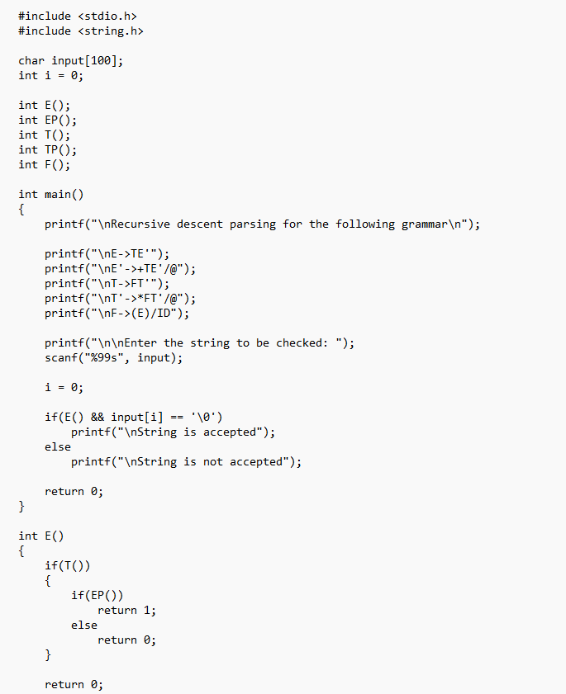
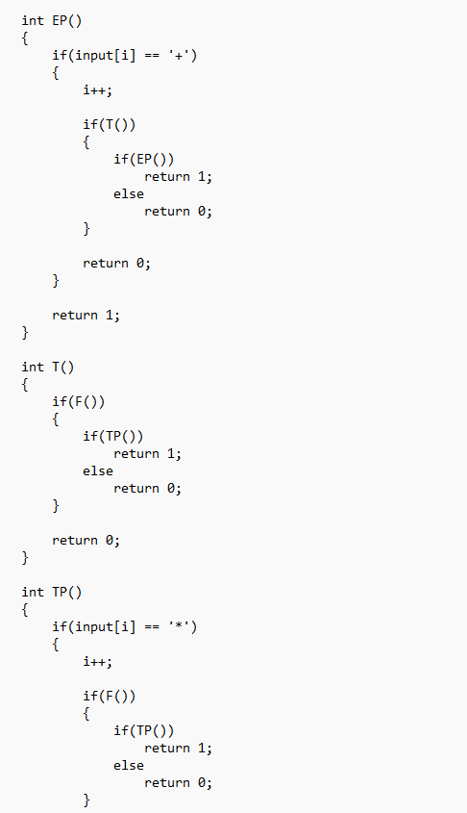
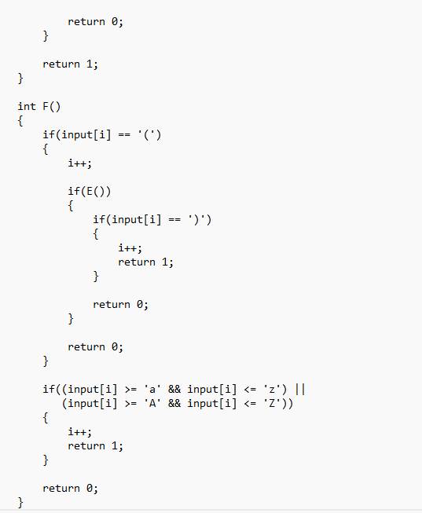

OUTPUT:-
